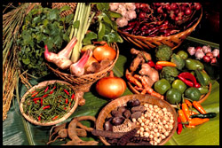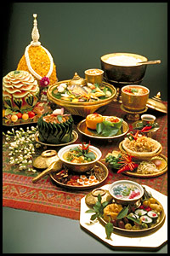
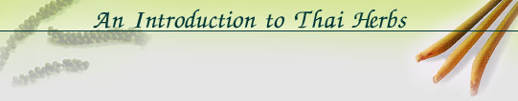
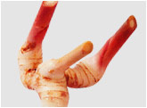
Galangal or "Kha"
Greater galangal is an erect annual plant with aromatic, ginger-like rhizomes, and is commonly used in Thai cooking as a flavouring. The approximately 0.04% volatile oil content has therapeutic uses as carminative, stomachic, antirheumatic and antimicrobial agents.
An essential ingredient in the preparation of the Thai version of red curry paste, Galangal is used in popular dishes such as the shrimp soup with lemon grass - Tom Yam Goong, chicken soup with coconut milk-Tom Kha Gai, stir-fried meat or vegetables in a dry red curry paste - Phad Prik Khing, a fish curry sauce - Khanom Jeen Nam Ya - and a Northern Thai curry called Hang Le.
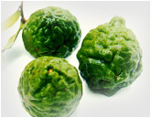 | Kaffir Lime leaves or "Ma-Kroot"  Kaffir Lime is sometimes called by its other names - Leech Lime, Mauritus Papeda or Porcupine Orange. The leaves, peel and juice of the Kaffir Lime are used as a flavouring in Thai cuisine. The leaves and peel contain volatile oil. The major therapeutic benefit of the juice is as an appetizer.  Kaffir Lime leaves are a key ingredient in red curry paste, and dishes such as a Southern-style rice salad - Khao Yam Pak Tai, steamed fish mouse - Haw Mok Talay, and Phad Prik Khing.
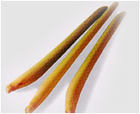 | Lemongrass or "Ta Khrai"  This erect annual plant resembles a coarse lemon-scented grey-green grass. Fresh leaves and grass are used as a flavouring. Lemongrass contains 0.2 - 0.4 volatile oil and has several therapeutic properties.  Lemon grass is used in many forms - as whole leaves and stalks, sliced or pounded - and is featured in most Thai dishes ranging from soups and Thai salads, particularly "pla", curry paste and curries. The distinctive but delicate aroma of lemon grass is refreshing and invigorating.
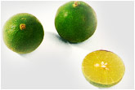 | Lime or "Ma-Nao"  Lime is used principally as a garnish for fish and meat dishes. The fruit contains Hesperidin and Naringin, scientifically proven anti-inflammatory flavonoids. Lime juice is used as an appetizer, and has antitussive, antiflu, stomachic and antiscorbutic properties.
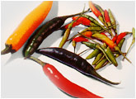 | Chilli or "Prik"  Chilli is an erect, branched shrub-like herb with fruits used as garnishing and flavouring in Thai dishes. There are many different species. All contain capsaicin, a biologically active ingredient beneficial to the respiratory system, blood pressure and heart. Chilli has many other therapeutic uses.
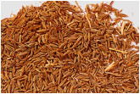 | Cumin or "Yi-ra"  (Cummin, Zeera)  Cumin is a small shrubbery herb, the fruit of which contains 2 to 4% volatile oil with a pungent odour, and which is used as a flavouring and condiment. Cumin's therapeutic properties manifest as a stomachic, bitter tonic, carminative, stimulant and astringent.
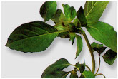 | Hoary Basil or "Maeng Lak"  Hoary Basil is an annual herbaceous plant with slightly hairy and pale green leaves,  eaten either raw or used as a flavouring. Containing 0.7% volatile oil, its therapeutic benefits include the alleviation of cough symptoms, and as diaphoretic and carminative agents.
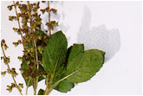 | Sacred Basil or "Ka-Praow"  Sacred Basil is an annual herbaceous plant that ressembles Sweet Basil but has narrower and often-times reddish-purple leaves. The fresh leaves, which are used as a flavouring, contain approximately 0.5% volatile oil, which exhibit antimicrobial activity specifically as a carminative, diaphoretic, expectorant and stomachic.  The popular 'one plate' Thai fast-food choice of stir-fried meat or seafood dish, "Pad Ka-Praow" is tasty local favourite.
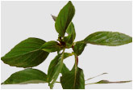 | Sweet Basil (Common Basil) or "Ho-Ra-Pa"  Sweet Basil is an annual herbaceous plant, the fresh leaves of which are either eaten raw or used as a flavouring in Thai cooking. Volatile oil content varies according to different varieties. Therapeutic properties are as carminative, diaphoretic, expectorant, digestant and stomachic agents.  Horapa Sweet Basil is commonly found in variety of steamed, oven-baked or stir-fried seafood and mussel dishes such as the spicy seafood soup- Poh Taek, Haw Mok Talay  seafood mouse, and sautéed prawns in a drier stir-fried red curry paste, Chu Chee Goong Lai
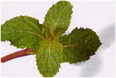 | Marsh Mint or "Sa-ra-nae"  The fresh leaves of this herbaceous plant are used as a flavouring and is eaten raw in Thai cuisine. Small sprigs are also used for garnishing. Volatile oil contents give the plant several therapeutic uses as a carminative, mild antiseptic, local anaesthetic, diaphoretic and digestant properties hence adds a refreshing taste to Thai salads  such as the spicy "yam" or the more delicate "pla".
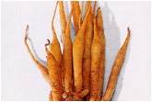 | "Kra-Chai"  This erect annual plant with aromatic rhizomes and yellow-brown roots is used as a flavouring. The rhizomes contain approximately 0.8% volatile oil. Some of its therapeutic benefits include the relief of stomach aches and stomach discomfort, antimicrobial properties, and antitussive agent relieving or preventing coughing.  Krachai is a key ingredient of Gaeng Som, a spicy soup often featuring fish or seafood, and other chilli paste, and a fish curry sauce - Khanom Jeen Nam Ya.
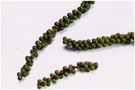 | Pepper or "Prik Thai"  Pepper is a branching, perennial climbing plant from whose fruiting spikes, both white and black pepper are obtained. Used as a spice and condiment, Pepper contains 2 to 4% volatile oil. Therapeutic uses are as carminative, antipyretic, diaphoretic and diuretic agents.
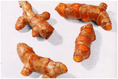 | Tumeric (Curcuma, Indian Saffron, Yellow Root) or "Khamin"  Tumeric is a member of the ginger family, and provides yellow colouring for Thai food. The rhizomes contain 3 to 4% volatile oil with unique aromatic characteristics. Tumeric's properties manifest as carminative and stomachic agents.  The use of tumeric predominates in the dishes of Southern Thailand.  Shallots are sliced, deep-fried, pounded in red curry or chilli paste, pickled, or used as garnish, and is prominently featured in northern dishes such as Hang Le Curry, the northern style chilli dip - Nam Prik Ong, and the northern-style chicken curry noodle soup - Khao Soi, the spicy soup Gaeng Som and the Thai salads of the Central Plains.
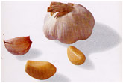 | Garlic or "Kra-thiam"  Garlic is an annual herbaceous plant with underground bulbs comprising several cloves. Dried mature bulbs are used as a flavouring and condiment in Thai cuisine. The bulbs contain 0.1 to 0.36% garlic oil and organic sulfur compounds. It is known for its therapeutic properties as antimicrobial, diaphoretic, diuretic, expectorant, cholesterol lowering and agents to relieve stomach discomfort.
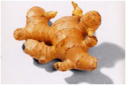 | Ginger or "Khing"  Ginger is an erect plant with thickened, fleshy and aromatic rhizomes. Used in different forms as a food, flavouring and spice. Ginger rhizomes contain 1 to 2% volatile oil and is often used as carminative and agents to ease prevent or alleviate nausea and relieves stomach discomfort.

